Analysis Of The Effectiveness Of Government Accounting System Digitalization On Financial Reporting Quality In Regional Governments Of East Kalimantan

¹Syafa Ananda Descianti, ²Rifandi Fauji Pratama, ³Rimi Gusliana Mais
^{1,2,3} Sekolah Tinggi Ilmu Ekonomi Indonesia Jakarta, Jakarta Timur, Indonesia
¹anandasyafa66@gmail.com, ²rifandifauzi05@gmail.com, ³rimi_gusliana@stei.ac.id.

*Correspodence Email: anandasyafa66@gmail.com

Abstract: This study aims to analyze the effectiveness of government accounting system digitalization regional government financial reports in five regional governments in East Kalimantan, namely Balikpapan City, Samarinda City, Kutai Kartanegara Regency, North Penajam Paser Regency, and Berau Regency. This research addresses the inconsistency of previous findings and the limited studies that comprehensively examine the effectiveness of government accounting system digitalization on regional financial reporting quality across different local government contexts, particularly in East Kalimantan. This study employs a qualitative descriptive approach. Secondary data were obtained from Regional Government Financial Reports (LKPD), BPK audit reports, and official regional government portals. The data were analyzed using descriptive and comparative analysis techniques. The results show that the implementation of the Regional Government Information System (SIPD) has generally been effective in improving financial management, particularly in terms of system integration, data accuracy, reporting timeliness, and transparency. The achievement of Unqualified Opinions (WTP) by all research objects indicates relatively good financial reporting quality. However, differences in human resource capacity, technological infrastructure, and system integration readiness still affect the effectiveness of digitalization across regions. The study contributes to the development of public sector accounting digitalization studies and provides practical recommendations for regional governments to improve digital infrastructure, employee competence, and system optimization to support transparent and accountable financial reporting.
Keywords: Government Accounting System Digitalization, Information System Effectiveness, Financial Report Quality, Transparency, Accountability.

INTRODUCTION
The development of modern governance requires increased transparency and accountability in the management of public finances. Regional governments, as entities managing public finances, have an obligation to present high-quality financial reports as a form of accountability to society and stakeholders (Amalia, 2023; Octavio & Urumsah, 2024). High-quality financial reports not only function as reporting tools but also serve as a basis for decision-making and evaluating the performance of regional governments (Rizki et al., 2024). Therefore, the quality of financial reports becomes an important indicator in realizing good governance and increasing public trust in government institutions.
Ideally, regional government financial reports must fulfill qualitative characteristics such as relevance, reliability, comparability, and understandability in accordance with Government Accounting Standards (Fauzi et al., 2025; Rizki et al., 2024). To achieve this, regional governments are required to implement effective accounting systems and utilize information technology in financial management and reporting processes (Aryani et al., 2024). The digitalization of government accounting systems using information technology and e-government is believed to improve efficiency, accuracy, and transparency in public financial management (Lestari, 2025; Mais et al., 2025). In the context of digital governance, the integration of digital government information systems also supports inter-organizational coordination and public value creation through data sharing and system integration (Wang et al., 2026). Furthermore, digital transformation in public organizations requires not only technological readiness but also organizational management, ethical governance and institutional adaptation to ensure effective implementation of digital systems (Pullen et al., 2026). Therefore, digitalization becomes a strategic instrument for improving the quality of regional government financial reports and strengthening public sector governance.
However, empirical conditions show that the implementation of government accounting system digitalization has not been fully optimal. Various problems are still found in the preparation of regional government financial reports, such as data inconsistencies, weak internal control, and non-compliance with applicable regulations (Hasibuan et al., 2024; Rizki et al., 2024). In addition, financial management practices that are still carried out manually or semi-manually cause risks of recording errors, reporting delays, and potential misuse of funds (Handayani et al., 2025). Previous studies on digital governance also reveal that ineffective organizational coordination, limited human resource competence, and insufficient integration among government information systems often hinder the effectiveness of digital transformation in the public sector (Pullen et al., 2026; Wang et al., 2026). Consequently, these conditions may negatively affect the quality, transparency, and accountability of regional government financial reports.
Previous studies have shown inconsistent findings regarding the relationship between digitalization accounting systems, and the quality of regional government financial reports. Research by Fiqih et al. (2024) found that accounting information systems did not significantly affect financial reporting quality, while internal control systems had significant effects. Similarly, Seman et al. (2025) reported that information technology had no significant effect on financial report quality, human resource competence and internal control significantly influenced reporting quality. In contrast, Lestari (2025) argued that digitalization of accounting systems improves transparency, efficiency, and accountability in public sector financial management. Furthermore, Fauzi et al. (2025) emphasized that the implementation of government accounting standards contributes positively to financial reporting quality despite several implementation barriers.
In addition to these Inconsistent findings, previous studies generally examined digitalization, accounting information system, internal control, and accounting standard separately or partially. Limited studies have comprehensively examined the effectiveness of government accounting system digitalization by integrating technological, organizational, and governance aspects in improving the quality of regional government financial reports. Moreover, international studies on digital governance mainly focus on public value creation, organizational coordination, and ethical governance in digital public administration (Pullen et al., 2026; Wang et al., 2026), while studies specifically discussing the effectiveness of government accounting system digitalization in regional financial reporting remain limited, particularly in the context of developing countries and regional governments.
Based on the identified research gap, the novelty of this study lies in its comprehensive approach to examining the effectiveness of government accounting system digitalization on the quality of regional government financial reports. Unlike previous studies that mostly focused on individual variables, this study integrates digitalization, government accounting system, organizational management, and financial reporting quality into a unified analytical framework. In addition, this study employs the empirical context of five regional governments in East Kalimantan, a region that has received limited attention in previous literature despite its strategic role in supporting the development of the Nusantara Capital City (IKN).
Theoretically, this study contributes to the development of literature on digital governance and public sector accounting by expanding the understanding of how the digital accounting system, organization readiness, and governance mechanisms interact in improving financial reporting quality. Practically, this study provides insights and recommendations for regional governments regarding optimization of digital infrastructure, system integration and human resource competence to support transparent, accountable, and efficient regional financial management.

METHOD
Type and Research Approach
This study uses employed a qualitative descriptive approach to examine the effectiveness of government accounting system digitalization in improving the quality of regional government financial reports. A qualitative descriptive design was considered appropriate because the study aimed to explore and interpret the implementation of digital accounting systems within the context of public sector financial management without statistical hypothesis testing. According to Creswell (2009) and Miles et al. (2014), qualitative research is suitable for understanding social and organizational phenomena through contextual interpretation, while descriptive research allows researchers to systematically describe existing conditions and practices.
The use of this approach was also based on the nature of the study, which focused on evaluating the implementation of digital accounting systems, transparency practices, and financial reporting quality across different regional government contexts. Through this approach, the study was able to provide a comprehensive understanding of how digitalization supports accountability and transparency in regional financial governance.
Research Location and Time
This study was conducted in five regional governments in East Kalimantan Province, namely Balikpapan City, Samarinda City, Kutai Kartanegara Regency, North Penajam Paser Regency, and Berau Regency. The regions were selected because they represent different administrative characteristics, levels of regional development, and digital governance readiness. Such variation enabled a broader analysis of the implementation effectiveness of government accounting system digitalization.
The research was conducted in 2026 through several stages, including data collection, data classification, data analysis, and interpretation of findings. Data collection was carried out using desk research methods by reviewing official government documents, regional financial reports, transparency portals, and government websites.
Research Object and Subject
The object of this study was the effectiveness of government accounting system digitalization and its impact on the quality of regional government financial reports. The analysis focused on several indicators, including:
- System integration in regional financial management;
- Data accuracy based on audit findings and BPK opinions;
- Transparency and accessibility of financial information;
- Timeliness of financial reporting;
- Compliance with regional financial management regulations.
The units of analysis consisted of official government documents, including Regional Government Financial Reports (LKPD), Audit Reports issued by the Audit Board of the Republic of Indonesia (BPK), regional transparency portals, and other publicly accessible government documents.
Type and Sources of Data
This study uses secondary data obtained from various sources publicly accessible sources, including:
- Regional Government Financial Reports (LKPD);
- Audit Reports of the Audit Board of the Republic of Indonesia (BPK);
- Official regional government websites;
- Government transparency and open data portals;
- Laws and regulations related to regional financial management;
- Previous studies and scientific literature relevant to digital governance and public sector accounting.
The use of secondary data was considered appropriate because the study emphasized institutional analysis and evaluation of publicly documented financial management practices.
Data Collection Procedures
Data collection was conducted through documentation and literature review techniques. Documentation study involved collecting, reviewing, and classifying official documents related to regional financial management and digital accounting systems. The document included financial reports, audit reports, regional transparency data, and information available on official government digital platforms.
Literature review techniques were used to theoretical analysis and strengthen the interpretation of findings by reviewing previous studies related to digital governance, accounting information systems, public sector accountability, and financial reporting quality.
To ensure credibility and consistency of the data, this study applied source triangulation by comparing information obtained from multiple sources, such as BPK audit reports, official government websites, transparency portals, and supporting literature. According to Miles et al. (2014), triangulation is an important strategy in qualitative research to improve data validity and minimize interpretation bias.
Data Validation
Data validation was conducted through cross-checking information from different official sources to ensure consistency and reliability. The researcher compared financial reporting data, audit opinions, reporting timelines, and transparency information across government documents and public portals. In addition, only officially published documents and verified government sources were used in this study to maintain data credibility and accuracy.
Data Analysis Technique
The data were analyzed using qualitative descriptive analysis techniques adapted from Miles et al. (2014), consisting of three stages:
- Data reduction, which involved selecting, classifying, and focusing data relevant to the research objectives;
- Data presentation, which involved organizing findings in the form of narratives, comparisons, and tables to facilitate interpretation:
- Conclusion drawing and verification, which involved interpreting the findings to assess the effectiveness of government accounting system digitalization in improving the quality of regional government financial reports.
The analysis process was conducted systematically by comparing implementation conditions across regions and interpreting the findings based on the concepts of digital governance, transparency, accountability, and public sector financial management.

Research Framework
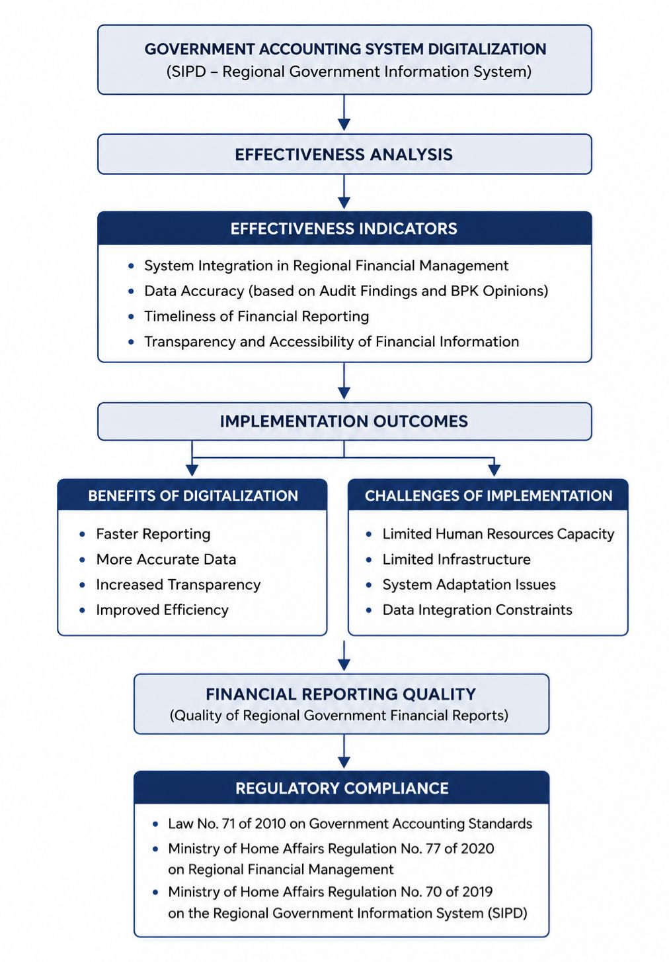
This study was based on the assumption that government accounting system digitalization contributes to improving the quality financial reports through better system integration, improved transparency, increased reporting accuracy, and timely financial reporting. The framework of the study begins with the implementation of digital accounting systems, followed by evaluation through effectiveness indicators, and ends with the assessment of financial reporting quality and accountability outcomes,

Figure 1. Research Framework of Government Accounting System Digitalization and Financial Reporting Quality

RESULT AND DISCUSSION
General Description of Research Objects
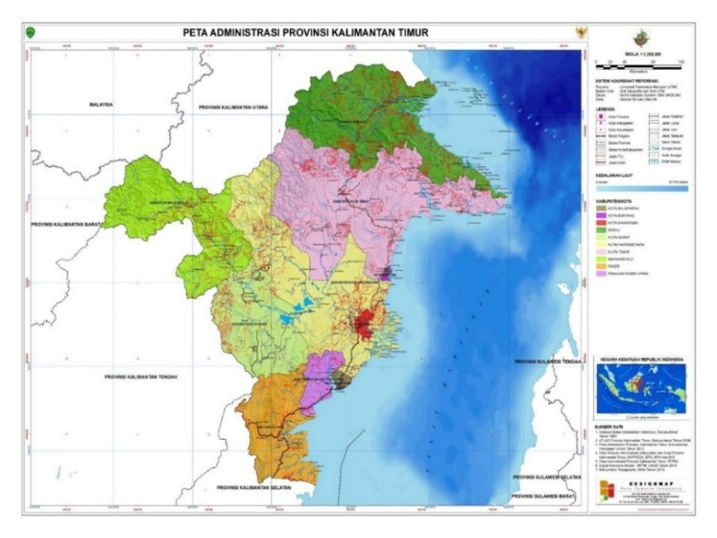
This study was conducted in five regions in East Kalimantan Province that have different characteristics in terms of regional development level, government governance, and regional potential. These differences become the basis for analyzing the effectiveness of government accounting system digitalization on the quality of regional government financial reports. Balikpapan City is known as an advanced city with a relatively high level of development, supported by adequate infrastructure and good governance. This makes Balikpapan one of the regions with more optimal digitalization readiness compared to other regions.
Figure 2. Administrative Map of East Kalimantan Province

Figure 2 presents the administrative map of East Kalimantan Province, illustrating the geographical distribution of the five regional governments included in this study.
Samarinda City, as the capital city of East Kalimantan Province, has a role as the administrative center of regional government. As an administrative city, Samarinda has an important function in managing government administration and regional finance, although it faces challenges in managing complex systems. Kutai Kartanegara Regency is a region with strong natural resource potential, especially in the mining and energy sectors. This condition creates complexity in regional financial management, thus requiring an accounting system capable of accommodating large and diverse transactions.

North Penajam Paser Regency is a strategic area because it is part of the Nusantara Capital City (IKN). The development of this region encourages increasing needs for a modern and integrated financial management system, including the implementation of government accounting system digitalization. Berau Regency is a developing region with continuously increasing economic potential, especially in the tourism and natural resource sectors. However, in terms of financial management and government accounting system digitalization, this region still faces various limitations, both in infrastructure and human resources.
The differences in regional characteristics indicate that the implementation of government accounting system digitalization is influenced not only by technology adoption, but also by governance capacity, infrastructure readiness, and organizational condition in each region. Therefore, these variations provide an important basis for comparing the effectiveness of digitalization in improving the quality of regional government financial reports across different local government contexts.
Analysis of the Effectiveness of Government Accounting System Digitalization
System Integration
Government accounting system digitalization in five regions of East Kalimantan was analyzed based on the use of regional financial information systems, the level of system integration, and the availability of website-based platforms as supporting tools for transparency. The main system used by regional governments is the Regional Government Information System (SIPD), developed by the Ministry of Home Affairs as an integrated system in regional financial management. This is evidenced by the availability of SIPD login access that has been specifically configured for all regions in the planning module (RPJMD), indicating that these regional governments have been integrated into the national system.
The integration of SIPD across regional governments indicates that digitalization has supported more coordinated and standardized financial management practices. In the context of digital governance, system integration is important because it helps reduce administrative fragmentation, improve data consistency, and strengthen accountability in regional financial management. These findings support Wang et al. (2026), who emphasized the integrated digital systems play an important role in improving coordination and governance effectiveness in public sector organizations. However, the effectiveness of system integration may vary across regions depending on technological readiness, infrastructure support, and organizational capacity.
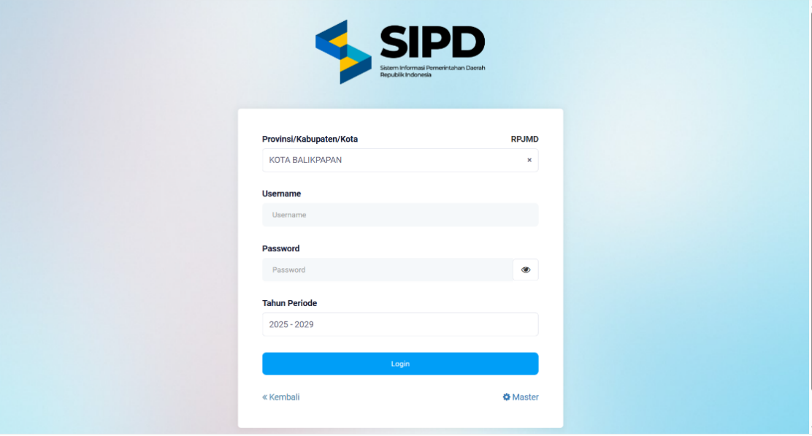

Figure 3. Regional Government Information System (SIPD) Login Interface
Figure 4 Regional Government Information System (SIPD) Login Interface

Data Accuracy (BPK Audit Reports)
Based on the Audit Board of the Republic of Indonesia (BPK) examination results in 2024, all regional governments that became research objects, namely Balikpapan City, Samarinda City, Kutai Kartanegara Regency, North Penajam Paser Regency, and Berau Regency, obtained Unqualified Opinions (WTP). These opinions indicate that the financial reports were fairly presented in all material respects in accordance with Government Accounting Standards.
No. | Regional Government | Opinion
1 | Balikpapan City | Unqualified Opinion
2 | Samarinda City | Unqualified Opinion
3 | Kutai Kartanegara Regency | Unqualified Opinion
4 | North Penajam Paser Regency | Unqualified Opinion
5 | Berau Regency | Unqualified Opinion
Table 1. BPK Audit Opinions of Regional Governments in East Kalimantan for Fiscal Year 2024
From the perspective of the data accuracy indicator, the achievement of Unqualified Opinions indicates that the financial data presented are relatively reliable and free from material misstatements. This shows that the processes of recording, processing, and financial reporting have been carried out properly. Although all regions obtained Unqualified Opinions, this does not automatically indicate that government accounting system digitalization has been fully optimal. Audit opinions emphasize the fairness of financial report presentation, not the effectiveness of the digital systems used in the preparation process.
In the context of government accounting system digitalization, this condition may reflect that systems used, such as SIPD, have supported improved data accuracy through more structured and integrated recording. However, Unqualified Opinions do not fully describe that digitalization has operated effectively. Therefore, effectiveness still needs to be further analyzed through other indicators such as system integration, timeliness of reporting, and the capability of human resources in operating digital accounting systems.
These findings indicate that the quality of financial reports is influenced not only by compliance with accounting standards, but also by organizational readiness and the effectiveness of digital system implementation. This finding is consistent with Seman et al. (2025), who emphasized that human resource competence and internal control systems play important roles in improving financial reporting quality in regional governments.
Transparency
Based on observations of transparency portals and open data platforms in each regional government, it is known that all regions have provided public information access through digital platforms. Balikpapan City has the “Satu Data Balikpapan” portal that provides various types of data in open formats such as tables and documents. Samarinda City also provides an Open Data portal that allows the public to access various datasets easily. Kutai Kartanegara Regency has an Open Data portal presenting regional statistical information and datasets in a structured manner. Berau Regency provides a geospatial portal displaying spatial-based data, while North Penajam Paser Regency provides information access through its official government website containing transparency and regional financial information.
Table 2 presents the availability of open data portals in each regional government as an indicator of transparency and public information accessibility.
No. | Regional Government | Website Link
1. | Balikpapan City | Data Balikpapan
2. | Samarinda City | Selamat Datang : Satu Data Samarinda
3. | Kutai Kartanegara Regency | Kominfo Kutai Kartanegara
4. | Penajam Paser Utara Regency | Welcome - SATU DATA
5. | Berau Regency | Satu-Data-Berau
Table 2. Open Data Portals of Regional Governments in East Kalimantan
The existence of these transparency portals shows that government accounting system digitalization has supported public information disclosure. In the context of effectiveness, the availability of open data is an important indicator in assessing financial information transparency. Easy access to public data reflects that the digital system is not only used for internal purposes, but also to improve accountability to society.
However, the level of transparency among regions varies in terms of data completeness, ease of access, and types of information presented. This indicates that although digitalization has been implemented, its effectiveness in supporting transparency is still different in each region. Thus, the existence of a digital system alone is not sufficient to guarantee openness of information. Consistent data management and commitment from each regional government are needed in presenting information that is easily accessible to the public.
These findings support the concept of digital governance, which emphasizes the role of information technology in improving transparency and public accountability in government institutions. The results are also consistent with Octavio & Urumsah (2024), who found that digital transparency initiatives contribute to broader public access to financial information and strengthen accountability practices in local governments.
Timeliness of Reporting
Based on the results of data tracing, all regional governments in East Kalimantan submitted the 2024 Regional Government Financial Reports (LKPD) to BPK on March 26, 2025 (Update Kaltim, 2025). The submission was carried out simultaneously and was still within the specified deadline, namely a maximum of three months after the fiscal year ended. This is also strengthened by information in news reports stating that the LKPD submission was conducted “on time” as a form of commitment by regional governments in accountable financial management.
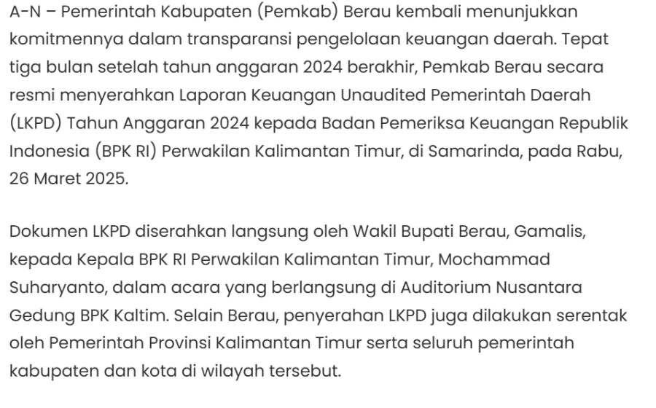
Figure 4 illustrates the submission of regional government financial reports to BPK as evidence of reporting timeliness and accountability.

Figure 4. Submission of Berau Regency’s 2024 Financial Reports to BPK
The timeliness of financial report submission indicates that the financial reporting preparation process has operated effectively. In the context of government accounting system digitalization, this condition indicates that the system used has been able to accelerate data processing and financial reporting processes. Thus, reporting timeliness can be an indicator that government accounting system digitalization has been effectively implemented in supporting the preparation of regional financial reports.
The timely submission of financial reports indicates that digital systems have contributed to improving administrative efficiency and regional financial management. Faster reporting processes may also support more effective decision-making and strengthen accountability in the public sector. This finding is in line with Lestari (2025), who argued that digitalization improves efficiency and reporting effectiveness in public financial management.
Analysis of the Impact of Government Accounting System Digitalization
Government accounting system digitalization has a dualistic impact, meaning that it provides significant benefits while also presenting several challenges in its implementation. From the positive side, the implementation of government accounting system digitalization such as the Regional Government Information System (SIPD) is able to improve efficiency and timeliness in preparing financial reports. Financial management processes that were previously carried out manually can now be conducted in an integrated and real-time manner, thereby accelerating report presentation and supporting faster and more accurate decision-making. Lestari (2025) and Ardheta et al. (2025) stated that digitalization plays a role in improving operational efficiency and the quality of public sector financial reporting.
These findings are also supported by empirical conditions in the field, where the central government through the Ministry of Home Affairs encourages all regional governments to implement SIPD as part of the digitalization of regional financial management. The implementation of SIPD is considered important to improve accountability, efficiency, and integration of regional financial data nationally (TVRI News, 2024). In addition, digitalization also plays a role in increasing transparency and openness of financial information to the public (Kementrian Keuangan, 2023).
However, behind these benefits, digitalization also faces several obstacles that affect its implementation effectiveness. One of the main obstacles is the limitation of human resources, especially in terms of digital literacy and technical capabilities of government employees. Several studies show that employee competence is a key factor in the successful implementation of accounting information systems (Mais et al., 2024; Seman et al., 2025). In addition, technological infrastructure constraints are also challenges, especially in regions with uneven levels of development. This condition is also reinforced by the fact that although most regions have adopted SIPD, there are still regions that have not fully optimized the use of the system, so assistance and acceleration of adaptation to digital systems are still needed (Antara News, 2024).
In the context of implementation at the regional level, government accounting system digitalization shows varying effectiveness influenced by the characteristics of each region. In Balikpapan City as a region with a high level of digital maturity, digitalization provides a relatively optimal impact in improving efficiency and transparency of regional financial management. The implementation of digital systems allows financial administrative processes to be carried out faster and more integrated, thus supporting reporting timeliness. In addition, financial transparency has also increased through the provision of information that can be accessed online by the public. This is supported by the implementation of digital financial services such as SP2D Online, which accelerates the disbursement process and increases accountability in regional financial management (inibalikpapan.com; pranala.co). However, high dependence on digital systems also creates risks, especially when technical disruptions occur that may hinder financial administrative processes.
In Samarinda City, digitalization plays an important role in supporting coordination among regional apparatus organizations and managing complex financial data. As an administrative center, digital systems help integrate various financial processes into one structured platform, thereby improving efficiency and reporting timeliness. However, organizational complexity also becomes a challenge, where the large number of work units involved has the potential to create data inconsistencies and delays in the input process if coordination is not carried out optimally.
In Kutai Kartanegara Regency, digitalization provides benefits in managing large and complex financial transactions, especially those related to the natural resource sector. Digital systems help improve orderly recording and strengthen supervision of regional budget utilization. However, data complexity and the large number of regional apparatus organizations involved create obstacles in data integration and synchronization, so system effectiveness is still influenced by the region’s ability to manage coordination and integration among work units.
Meanwhile, North Penajam Paser Regency shows different dynamics as a buffer region for the Nusantara Capital City (IKN). The digitalization of the accounting system in this region has accelerated along with the need for more modern government governance transformation. This is reflected in the improvement of regional financial management quality and the success in maintaining an Unqualified Opinion (WTP), indicating good accountability of financial reports (sambaranews.com). However, accelerated development and digitalization also require substantial infrastructure and resource readiness, where investment needs and system adaptation become the main challenges in digitalization implementation (merdeka.com).
In Berau Regency as a developing region, digitalization shows efforts to improve financial governance through the implementation of data-based systems such as E-Walidata integrated with SIPD. This system helps improve data quality and supports more systematic planning and budgeting processes. In addition, the regional government’s commitment to maintaining transparency can be seen from the timely submission of financial reports to BPK as a form of public accountability (beraukab.go.id; berita.rri.co.id). However, this region still faces obstacles in data integration and limitations in human resources, which affect the overall optimization of the digital system. The findings of this study indicate that each region has different levels of effectiveness and challenges in implementing government accounting system digitalization. The comparison can be seen in the following table.

Region | Positive Impact | Challenges
Balikpapan | High Efficiency, SP2D online | Risk of system disruption
Samarinda | Good OPD integration | Data synchronization
Kutai Kartanegara | Supervision of major Transactions | Data synchronization
Penajam Paser Utara | Rapid modernization | Requires large investment
Berau | E-Walidata, timely reporting | Limited human resources

Table 3. Comparative Summary of Government Accounting System Digitalization Across Regions
Based on the table above, Balikpapan City has a relatively better level of digitalization effectiveness compared to other regions, while Berau Regency still faces obstacles in data integration and human resources. Government accounting system digitalization has proven to provide positive impacts in improving efficiency, transparency, and the quality of regional government financial reports. However, the effectiveness of implementation still varies among regions and has not been fully optimal, because it is influenced by the readiness of human resources, technological infrastructure, and the level of organizational adaptation. Therefore, continuous efforts are needed in improving employee capacity, strengthening technological infrastructure, and optimizing system integration so that digitalization can provide maximum benefits for regional financial management.
Analysis of Compliance with Regional Financial Management Regulations
The analysis of compliance with regional financial management regulations was carried out by referring to Government Regulation Number 71 of 2010, Minister of Home Affairs Regulation Number 77 of 2020, and Minister of Home Affairs Regulation Number 70 of 2019. The indicators used include the conformity of financial report presentation, the use of SIPD, timeliness of LKPD submission, and BPK audit opinions. Based on the research results, all regions, namely Balikpapan City, Samarinda City, Kutai Kartanegara Regency, North Penajam Paser Regency, and Berau Regency, obtained Unqualified Opinions and submitted financial reports on time.
This shows that, in general, regional governments have fulfilled the main provisions in regional financial management. However, the level of implementation optimization still differs among regions, especially in aspects of system integration, human resource capacity, and infrastructure support. Overall, compliance with regulations in the five research regions is classified as good. These findings indicate that the implementation of regional financial regulations has been quite effective and supported by the increasingly developing use of digital systems. Such compliance becomes an important foundation in realizing orderly, transparent, and accountable regional financial governance.
These findings indicate that regulatory compliance plays an important role in supporting the effectiveness of government accounting system digitalization. Compliance with financial management regulations not only strengthens administrative accountability but also supports the standardization and consistency of digital financial reporting practices across regional governments. This finding is consistent with Fauzi et al. (2025), who emphasized the importance of government accounting standards in improving the quality of public financial reports.

CONCLUSION
This study concludes that the digitalization of government accounting systems has generally contributed to improving the quality of regional government financial reports in East Kalimantan. The implementation of the Regional Government Information System (SIPD) has supported better system integration, improved data accuracy, increased transparency, and more timely financial reporting. These improvements are reflected in the achievement of Unqualified Opinions (WTP) and the timely submission of financial reports by all regional government examined in this study. The effectiveness of digitalization still varies across regions due to differences in human resource capacity, technological infrastructure, organizational readiness, and system integration. Regions with better digital readiness and governance tend to achieve more optimal implementation results compared to regions that still face infrastructure and adaption challenges. The main contribution of this study is providing a clearer understanding of how government accounting system digitalization can improve the quality of regional government financial reports. Unlike previous studies that mostly focused on specific aspects, this study examines the role of digital systems, organizational readiness, and financial governance and public sector accounting, especially in regional government in the developing countries such as Indonesia.
The findings of this study can be used as a reference for regional governments and policymakers in improving digital infrastructure, strengthening employee competence, and optimizing the integration of financial information systems to support transparent and accountable financial governance. This study has several limitations. First, the study relied only on secondary data obtained from official documents and public information portals without direct interviews or field observations. Second, the research focused only on five regional governments in East Kalimantan, which may limit the generalization of findings to other regions. Future research is recommended to involve broader regional coverage, use quantitave or mixed-method approaches, and include interviews or direct observations to obtain a deeper understanding of the implementation and effectiveness of government accounting system digitalization in regional financial management.

REFERENCE
Amalia, M. M. (2023). Enhancing accountabilitiy and tranparency in the public sector: A comprehensive review of public sector accounting practices. The ES Accounting and Finance, 1(03), 160–168. https://doi.org/10.58812/esaf.v1i03.105
Ardheta, P. A., Mustika, M., Mais, R. G., & Safitri, A. (2025). The impact of stakeholder pressure on sustainability reporting. Jurnal Akuntansi Dan Manajemen, 22(01), 27–38. https://doi.org/10.36406/jam.v22i1.33
Aryani, W., Widodo, T., & Puspita, M. E. (2024). Sistem akuntansi keuangan daerah, kompetensi SDM dan audit internal terhadap kualitas laporan keuangan pemerintah daerah. Edunomika, 08(04), 1–18. https://doi.org/10.29040/jie.v8i4.12899
Creswell, J. W. (2009). Research design: Qualitative, quantitative, and mixed methods approaches (3rd ed.). SAGE Publications, Inc. John W. Creswell Official Website
Fauzi, Minarni, E., & Hartono. (2025). Implementation of government accounting standards in improving the quality of public financial reports. The Journal of Academic Science, 2(2), 578–586. https://doi.org/10.59613/j3jqvt63
Handayani, A., Anisa, Effriyanti, & Faozi, K. (2025). Digitalisasi laporan keuangan sebagai upaya transparansi dan akuntabilitas BUMDes Bebedahan Berkah. PaKMas (Jurnal Pengabdian Kepada Masyrakat), 5(1), 137–145. https://doi.org/10.54259/pakmas.v5i1.3315
Hasibuan, I. M. S., Irfan, Sari, M., & Sari, E. N. (2024). Moderation of government accounting standards in the realtionship of public accountability and public transparency. KAJIAN AKUNTANSI, 25(1), 121–130.
Lestari, P. A. (2025). Transparency and accountability in the digital era : Insights from public sector accounting. Sinergi International Journal of Accounting and Taxation, 3(3), 195–208. https://doi.org/10.61194/ijat.v3i3.864
Mais, R. G., Hendra, L., Alimurni, S., & Maliki, F. (2024). Corporate sustainability performance: The role of the gender diversity of the board and enterprise risk management. Jurnal Ilimiah Wahana Akuntansi, 19(1), 51–66. https://doi.org/10.21009/Wahana.19.014
Mais, R. G., Wulaningsih, R. W., Oktasari, E., Setiawan, D. A., & Wulandari, W. (2025). Artificial intelligence (AI) dalam akuntansi: Peluang dan tantangan untuk profesi akuntan. Jesya, 8(1), 751–765. https://doi.org/10.36778/jesya.v8i1.1976
Miles, M., Huberman, A. M., & Saldaña, J. (2014). Qualitative data analysis: A methods sourcebook (3rd ed.). SAGE Publications, Inc. SAGE Publications Official Website
Octavio, M. F. R., & Urumsah, D. (2024). Exploring factors influencing digital transparency in local government: Practices in Indonesia. Jurnal Dinamika Akuntansi Dan Bisnis, 11(02), 279–296. https://doi.org/0.24815/jdab.v11i2.39361
Pullen, E., Ruijer, E., & Meijer, A. (2026). Governing ethics for the digital transformation : Developing, testing, and validating a framework. Government Information Quarterly, 43(2), 102117. https://doi.org/10.1016/j.giq.2026.102117
Rizki, M. F. J., Wahyudi, I., & Olimsar, F. (2024). Pengaruh sistem informasi akuntansi dan sistem pengendalian internal terhadap kualitas laporan keuangan pemerintah daerah (Studi pada Badan Pengelolaan Keuangan dan Pendapatan Daerah [BPKD] Provinsi Jambi. Jurnal Manajemen Terapan Dan Keuangan (Mankeu), 13(05). https://doi.org/10.22437/jmk.v13i05.36484
Seman, H., Afrino, Y., Yuliani, P., & Wahyudi, A. (2025). Determinasi kualitas laporan keuangan pemerintah daerah Kabupaten Manggarai Barat. Artikel Ilmiah Sistem Informasi Akuntansi, 5(2), 40–46. https://jurnal.bsi.ac.id/index.php/akasia/article/view/10180
Wang, Y., Sun, X., Xiong, W., & Onishi, M. (2026). Beyond technology : Exploring public value creation mechanisms and outcomes in platform-to-government data sharing. Government Information Quarterly, 43(2), 102129. https://doi.org/10.1016/j.giq.2026.102129

